**Module -2**

**1. What is Virtualization and its Types in Cloud Computing?**

“Virtualization in cloud computing is the process of creating virtual instances of physical resources like servers, storage, and networks. This technology allows multiple virtual machines (VMs) to run on a single physical machine, optimizing resource usage and providing flexibility.

Types of Virtualizations in Cloud Computing:

* Server Virtualization: Divides a physical server into multiple virtual servers, each running its own operating system and applications. This is fundamental for Infrastructure-as-a-Service (IaaS) solutions.
* Storage Virtualization: Combines multiple physical storage devices into a single virtual storage unit, enhancing storage management and scalability.
* Network Virtualization: Creates virtual networks that operate independently of the physical network infrastructure, improving network management and security.
* Desktop Virtualization: Allows users to run desktop environments on virtual machines hosted on a central server, facilitating remote access and management.
* Application Virtualization: Separates applications from the underlying hardware and operating system, allowing them to run in isolated environments.”

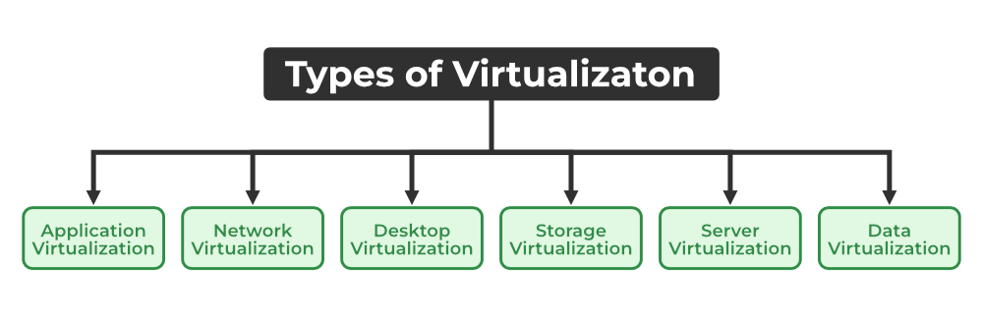

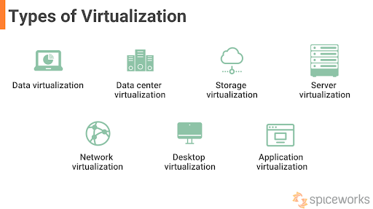

**2. Types of Hypervisors and How to Manage Them in Cloud Computing**

“A hypervisor is software that creates and manages virtual machines. There are two main types of hypervisors used in cloud computing:

* Type 1 Hypervisor (Bare Metal): Runs directly on the host’s hardware to manage guest operating systems. Examples include VMware ESXi, Microsoft Hyper-V, and Xen. These are typically used in enterprise environments for their performance and scalability.
* Type 2 Hypervisor (Hosted): Runs on a conventional operating system as a software layer. Examples include VMware Workstation, Oracle VirtualBox, and Parallels Desktop. These are more suitable for development, testing, and desktop virtualization.

Managing Hypervisors:

* Type 1 Hypervisors: Managed through specialized management software like VMware vCenter for ESXi or System Centre Virtual Machine Manager (SCVMM) for Hyper-V. These tools provide centralized management, monitoring, and automation capabilities.
* Type 2 Hypervisors: Managed through the host operating system’s interface or dedicated management tools provided by the hypervisor vendor.”

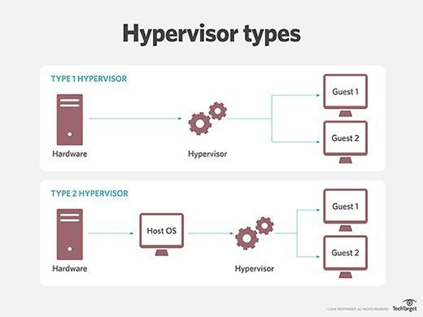

**3. Roles of Virtualization in Cloud Computing**

“Virtualization is a cornerstone of cloud computing, enabling efficient use of hardware resources and providing the foundation for cloud services. Here are some key roles:

* Resource Optimization: Virtualization allows cloud providers to maximize the utilization of physical hardware by running multiple virtual machines on a single server.
* Scalability: Virtualization enables dynamic scaling of resources to meet varying workload demands. Users can easily provision or de-provision virtual machines based on their needs.
* Isolation and Security: Virtual machines run in isolated environments, ensuring that issues in one VM do not affect others. This isolation enhances security and stability.
* Cost Efficiency: By abstracting physical hardware into virtual resources, virtualization reduces the need for physical servers, lowering costs related to hardware, maintenance, and energy consumption.
* Flexibility and Agility: Virtualization allows for rapid deployment and migration of virtual machines, making it easier to manage and adapt to changing business requirements.”

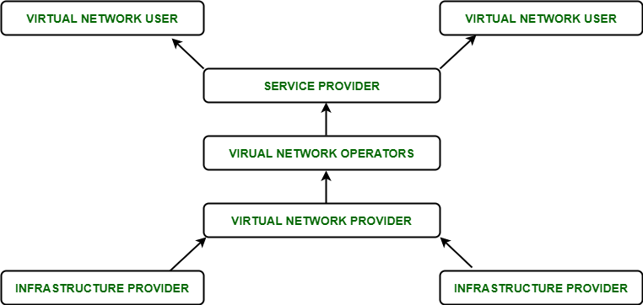

**4. What is a Container in Cloud Computing?**

“A container is a lightweight, standalone, and executable software package that includes everything needed to run an application: code, runtime, system tools, libraries, and settings. Containers are designed to be portable and consistent across different environments, from development to production.

Key Features of Containers in Cloud Computing:

* Isolation: Containers isolate applications from their environment, ensuring consistent behaviour regardless of where they are run.
* Efficiency: Containers share the host system’s kernel, making them more efficient and faster to start compared to virtual machines.
* Portability: Containers can run on any system that supports containerization, making it easy to move applications between different environments.
* Scalability: Containers can be easily scaled up or down to handle varying loads, making them ideal for microservices architectures and cloud-native applications.”

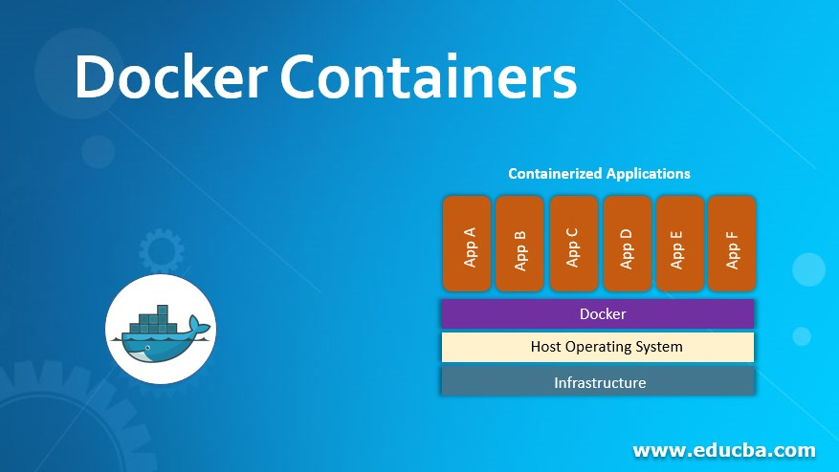

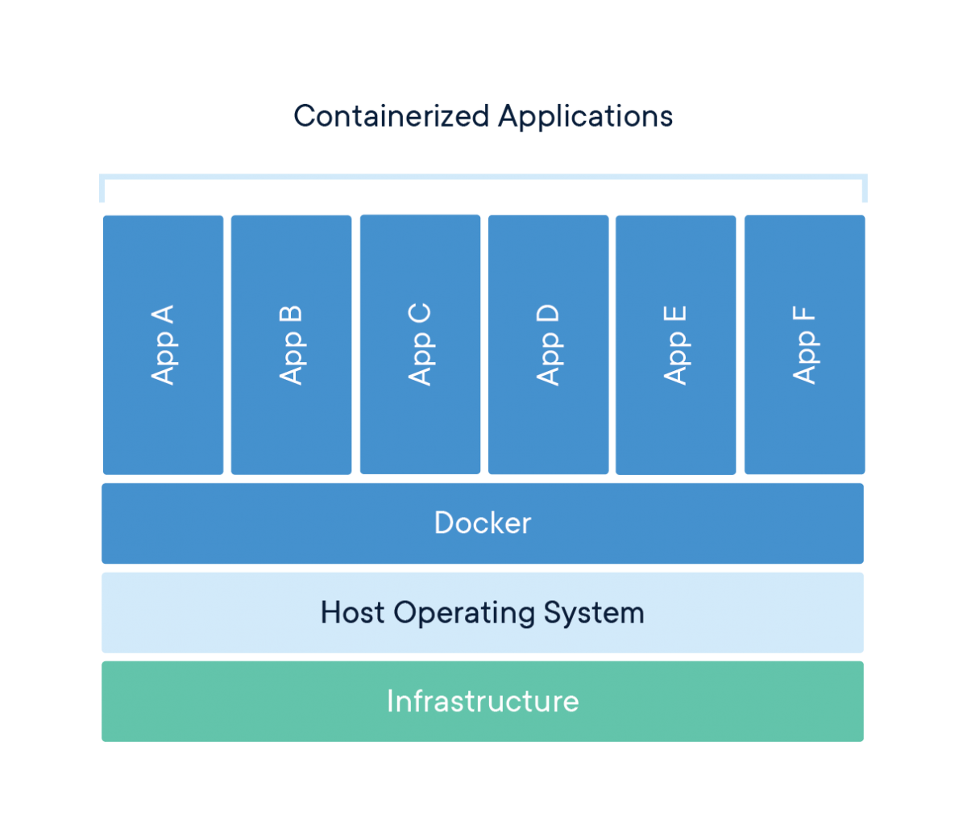

**5. What is High Availability and Live Migration in Virtualization?**

“High Availability (HA) in virtualization ensures that virtual machines (VMs) and applications remain operational even in the event of hardware or software failures. HA is achieved through redundancy and failover mechanisms, which automatically detect failures and restart VMs on other available hosts within a cluster.

Live Migration is the process of moving a running VM from one physical host to another without downtime. This is crucial for maintenance, load balancing, and disaster recovery1. Live migration ensures that applications continue to run smoothly while the underlying infrastructure is updated or repaired.”

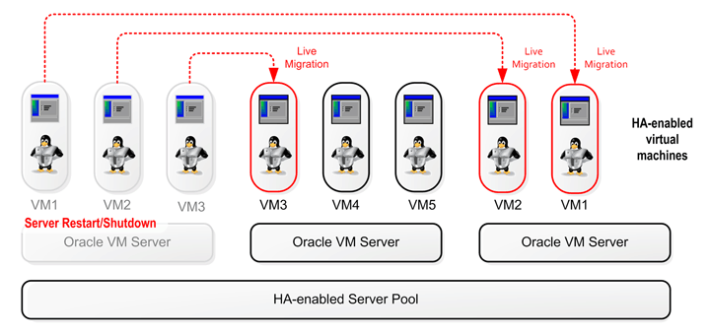

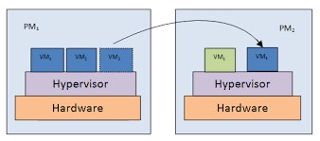

**6. Storage Configuration: Block Storage, File Storage, and Object** Storage

* Block Storage:

Description: Data is stored in fixed-sized blocks. Each block has a unique address, and the storage system manages these blocks.

Use Cases: Databases, virtual machines, and transactional applications.

Example: Storage Area Network (SAN), Direct-Attached Storage (DAS).

* File Storage:

Description: Data is stored as files in a hierarchical structure. It is accessed via file paths.

Use Cases: File sharing, home directories, and content repositories.

Example: Network-Attached Storage (NAS).

* Object Storage:

Description: Data is stored as objects, each with a unique identifier and metadata. It is designed for scalability and managing large amounts of unstructured data.

Use Cases: Backup, archival, and media storage.

Example: Amazon S3, OpenStack Swift.

* DAS, NAS, and SAN:

DAS (Direct-Attached Storage): Storage directly connected to a server or workstation. It is simple and cost-effective but lacks scalability and flexibility.

NAS (Network-Attached Storage): Storage connected to a network, providing file-level access to multiple clients. It is ideal for file sharing and collaboration.

SAN (Storage Area Network): High-speed network of storage devices providing block-level access. It is suitable for high-performance applications and large-scale virtualization.”

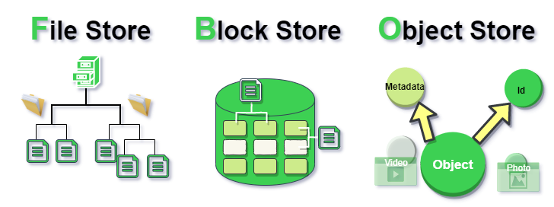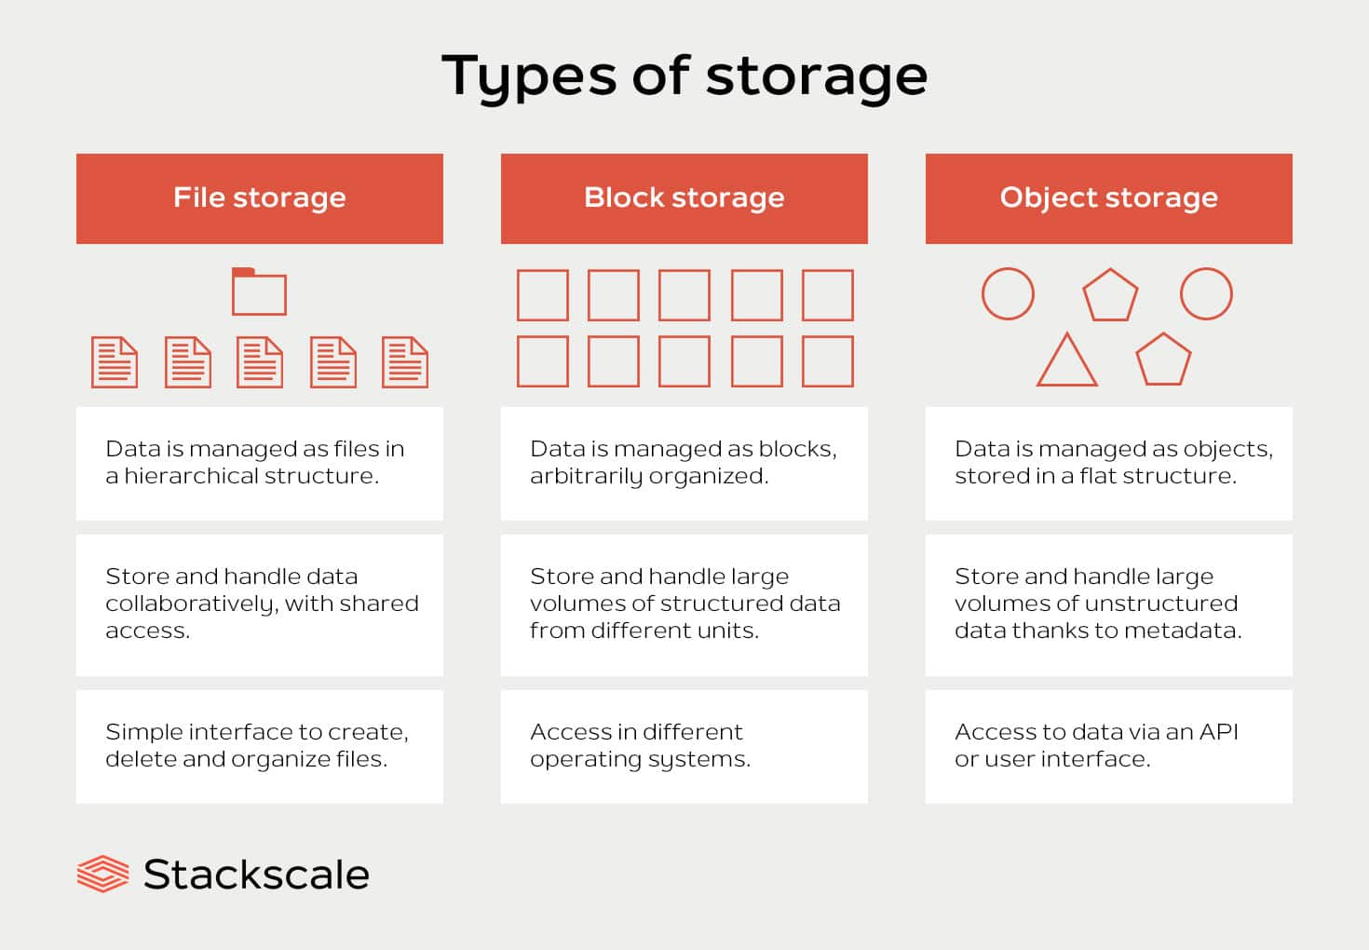

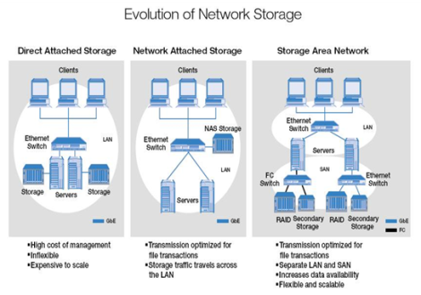

**7. Storage Allocation and Provisioning**

“Storage Allocation refers to the process of assigning storage resources to different applications, users, or services. It ensures that each entity has the necessary storage capacity to function efficiently.

Storage Provisioning involves the allocation and management of storage resources to meet the dynamic needs of an organization. There are two main types:

Thick Provisioning: Allocates a fixed amount of storage space upfront. This ensures predictable performance but can lead to inefficient use of storage capacity.

Thin Provisioning: Allocates storage space on-demand, based on actual usage. This optimizes storage utilization and reduces costs but may lead to performance issues if not managed properly.

Provisioning Strategies:

Advanced Provisioning: Involves detailed contracts and fixed pricing structures. It is suitable for businesses with stable and predictable workloads.

Dynamic Provisioning: Automatically allocates resources based on current needs. It is flexible and cost-effective, ideal for businesses with variable workloads.”

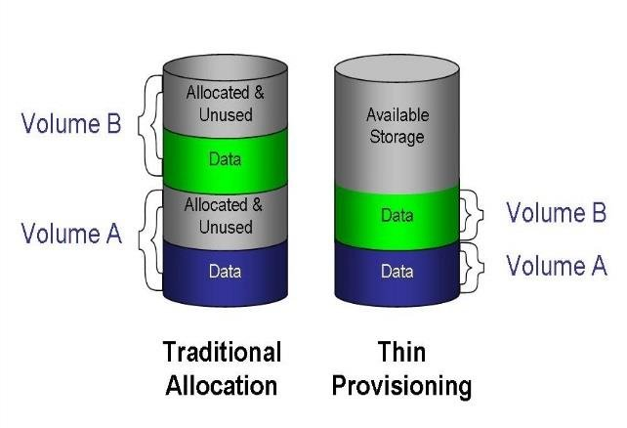

s